



**Hospital Management System**

**Introduction**

The Zenith Medical Center Management System is a database project designed to streamline and organize the operations of a hospital through a structured relational database. This system helps manage patient records, doctor information, staff roles, appointments, inpatients, consultations, medication details, billing, and feedback—all in one centralized platform. The aim of this project is to minimize manual effort, reduce errors, ensure data integrity, and provide quick access to important medical and administrative information. The system is scalable, secure, and can be extended with additional features in the future to support hospital digitalization.

**Objectives**

The main objectives of the Zenith Medical Management System are:

1. Efficient Data Management
2. Real-Time Information Access
3. Streamlined Consultation and Admission Tracking
4. Automated Billing Process
5. Role-Based Data Access
6. Medication and Inventory Monitoring
7. Feedback and Quality Improvement
8. Reduction in Manual Errors
9. Scalability and Integration

**Problem Statement**

In many hospitals, traditional methods of managing data—such as paper-based records or basic spreadsheets—often lead to inefficiencies, data duplication, and errors in patient care. These manual systems make it difficult to retrieve critical information quickly, manage billing accurately, or maintain a proper history of consultations and treatments. As the number of patients, staff, and services grows, so does the complexity of hospital operations.

There is a pressing need for an automated and structured database system that can streamline these operations, reduce manual workload, and ensure accurate and real-time access to information. The Zenith Medical Center Management System addresses these challenges by offering a centralized digital platform for managing all aspects of hospital administration.

**Entity Relationship Diagram**

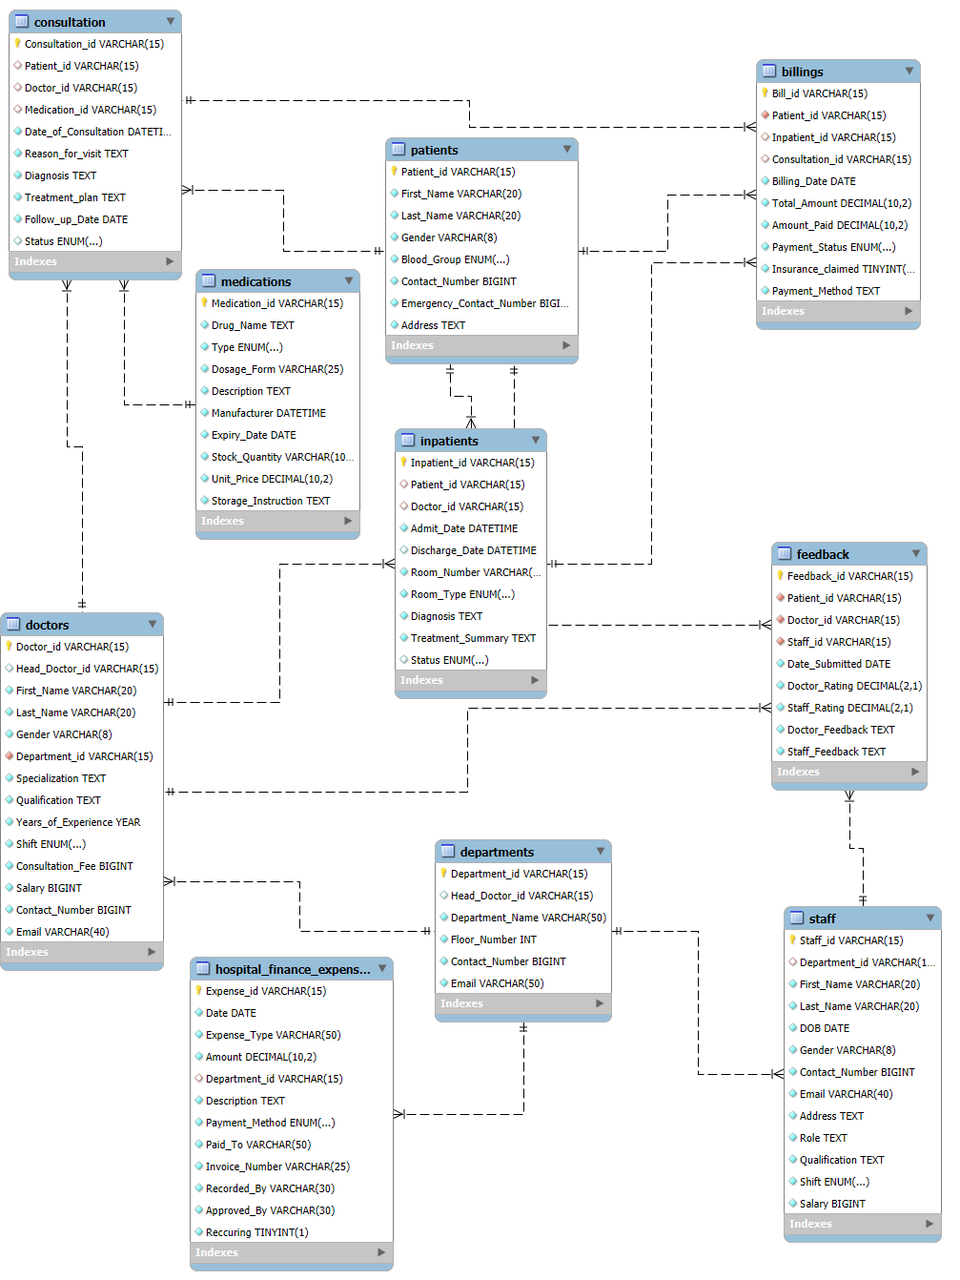

**Flow Structure**

1. **Patients:** Stores personal, contact, and medical details of individuals receiving healthcare services.
2. **Doctors:** Contains information about all registered doctors including specialization, department, and shift details.
3. **Departments:** Represents various hospital departments along with contact info and their head doctor assignments.
4. **Consultation:** Records all doctor-patient consultation details including diagnosis, treatment plans, and follow-up dates.
5. **Inpatients:** Captures data for patients admitted into the hospital, including room info, diagnosis, and discharge details.
6. **Medications:** Holds data about prescribed drugs, their dosage, expiry, storage instructions, and stock details.
7. **Staff:** Stores personal and professional information of non-doctor staff like nurses, technicians, and admin roles.
8. **Hospital Finance Expenses:** Records all financial expenditures incurred by the hospital
9. **Billings:** Manages financial transactions for consultations and admissions, including payment status and method.
10. **Feedback:** Collects feedback and ratings from patients regarding doctors and staff performance.

**My SQL Schema Design**

# Create Database 🡪 Zenith_Medical_Center

CREATE DATABASE if not exists Zenith_Medical_Center;

# Use Zenith_Medical_Center Database

USE Zenith_Medical_Center;

**[RDBMS] Flow Structure: Create Tables in** Zenith_Medical_Center **Database**

CREATE TABLE Patients (

Patient_id VARCHAR(15) PRIMARY KEY UNIQUE NOT NULL,

First_Name VARCHAR(20) NOT NULL,

Last_Name VARCHAR(20) NOT NULL,

Gender VARCHAR(8) NOT NULL,

Blood_Group ENUM('A+', 'A-', 'B+', 'B-', 'AB+', 'AB-', 'O+', 'O-') NOT NULL,

Contact_Number BIGINT UNIQUE NOT NULL,

Emergency_Contact_Number BIGINT UNIQUE NOT NULL,

Address TEXT NOT NULL

);

CREATE TABLE Doctors(

Doctor_id varchar(15) Primary key unique not null,

Head_Doctor_id varchar(15) unique,

First_Name varchar(20) not null,

Last_Name varchar(20) not null,

Gender varchar(8) not null,

Department_id varchar(15) not null,

foreign key (department_id) references Departments(department_id),

Specialization text not null,

Qualification text not null,

Years_of_Experience year not null,

Shift enum('Morning','Evening','Night')Default('Morning') not null,

Consultation_Fee bigint not null,

Consultancy_Fee bigint not null,

Contact_Number bigint unique not null,

Email varchar(40) unique not null

);

CREATE TABLE Departments (

Department_id VARCHAR(15) PRIMARY KEY,

Head_Doctor_id VARCHAR(15),

Department_Name VARCHAR(50) NOT NULL,

Floor_Number INT NOT NULL,

Contact_Number BIGINT UNIQUE NOT NULL,

Email VARCHAR(50) UNIQUE NOT NULL

);

CREATE TABLE Consultation (

Consultation_id varchar(15) Primary key unique not null,

Patient_id varchar(15),

foreign key (Patient_id) references Patients(Patient_id),

Doctor_id varchar(15),

foreign key (Doctor_id) references Doctors(Doctor_id),

Medication_id varchar(15),

foreign key (Medication_id) references Medications(Medication_id),

Date_of_Consultation datetime not null,

Reason_for_visit text not null,

Diagnosis text not null,

Treatment_plan text not null,

Follow_up_Date date not null,

Status enum('Scheduled','Completed','Cancelled')Default('Scheduled'));

CREATE TABLE Inpatients(

Inpatient_id varchar(15) primary key unique not null,

Patient_id varchar(15),

foreign key (Patient_id) references Patients (Patient_id),

Doctor_id varchar(15),

foreign key (Doctor_id) references Doctors (Doctor_id),

Admit_Date datetime not null,

Discharge_Date datetime,

Room_Number varchar(3)not null unique,

Room_Type enum('General','Private','I.C.U')not null,

Diagnosis text not null,

Treatment_Summary text not null,

Status enum('Admitted','Discharged','Transferred')default('Admitted'));

CREATE TABLE Medications (

Medication_id VARCHAR(15) PRIMARY KEY UNIQUE NOT NULL,

Drug_Name TEXT NOT NULL,

Type ENUM('Tablet', 'Syrup', 'Injection', 'Capsule') NOT NULL,

Dosage_Form VARCHAR(25) NOT NULL,

Description TEXT NOT NULL,

Manufacturer DATETIME NOT NULL,

Expiry_Date DATE NOT NULL,

Stock_Quantity VARCHAR(100) NOT NULL,

Unit_Price DECIMAL(10 , 2 ) NOT NULL,

Storage_Instruction TEXT NOT NULL);

CREATE TABLE Staff(

Staff_id varchar(15) primary key unique not null,

Department_id varchar(15),

foreign key (Department_id) references Departments (Department_id),

First_Name varchar(20) not null,

Last_Name varchar(20) not null,

DOB date not null,

Gender varchar(8) not null,

Contact_Number bigint unique not null,

Email varchar(40) unique not null,

Address text not null,

Role text not null,

Qualification text not null,

Shift enum('Morning','Eveining','Night')default('Morning') not null,

Salary bigint not null);

Create table Hospital_Finance_Expenses(

Expense_id varchar(15) primary key unique not null,

Date date not null,

Expense_Type varchar(50) not null,

Amount Decimal(10,2) not null,

Department_id varchar(15),

foreign key (department_id) references Departments (department_id),

Description text not null,

Payment_Method enum('Cash','Card','Bank Transfer') not null,

Paid_To varchar(50) not null,

Invoice_Number varchar(25) not null,

Recorded_By varchar(30) not null,

Approved_By varchar(30) not null,

Reccuring boolean not null

);

CREATE TABLE Billings(

Bill_id varchar(15) primary key unique not null,

Patient_id varchar(15) not null,

foreign key (Patient_id) references Patients (Patient_id),

Inpatient_id varchar(15),

foreign key (Inpatient_id) references Inpatients (Inpatient_id),

Consultation_id varchar(15),

foreign key (Consultation_id) references Consultation (Consultation_id),

Billing_Date date not null,

Total_Amount decimal(10,2) not null,

Amount_Paid decimal(10,2) not null,

Payment_Status enum ('Paid','Unpaid','Insurance')not null,

Insurance_claimed Boolean not null,

Payment_Method text not null );

CREATE TABLE Feedback(

Feedback_id varchar(15) primary key not null unique,

Patient_id varchar(15) not null,

foreign key (patient_id) references patients (patient_id),

Doctor_id varchar(15) not null,

foreign key (Doctor_id) references Doctors (Doctor_id),

Staff_id varchar(15) not null,

foreign key (Staff_id) references Staff (Staff_id),

Date_Submitted date not null,

Doctor_Rating decimal(2,1)check(Doctor_Rating between 1 and 10) not null,

Staff_Rating decimal(2,1) check (Staff_rating between 1 and 10) not null,

Doctor_Feedback text not null,

Staff_Feedback text not null);

**Queries**

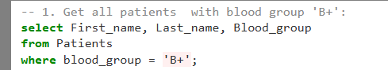

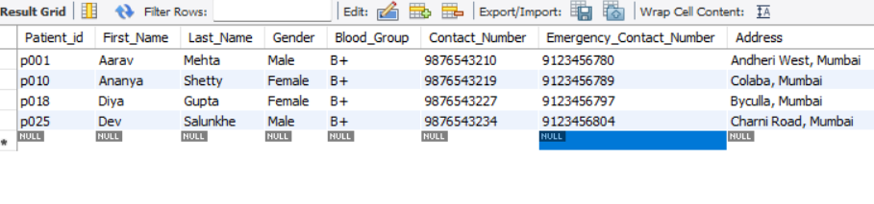

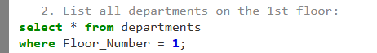

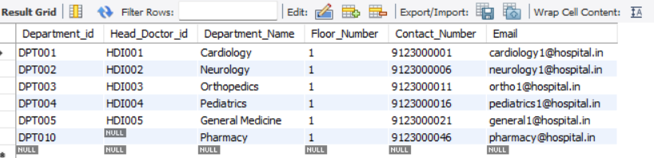



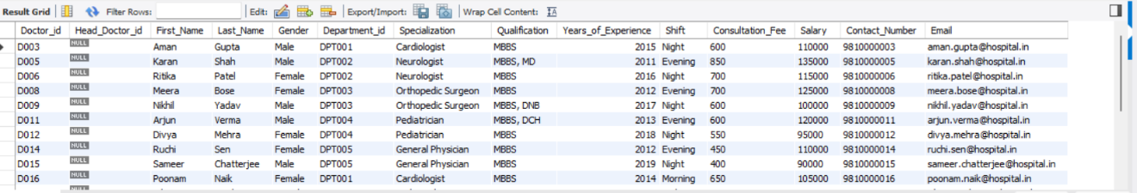

-- INTERMEDIATE QUERIES (4–16)

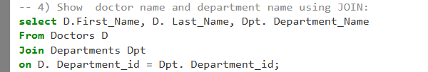

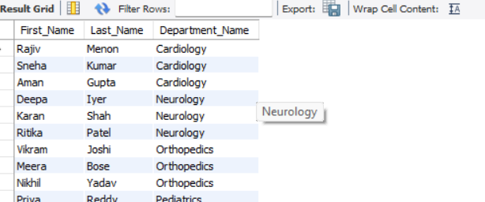

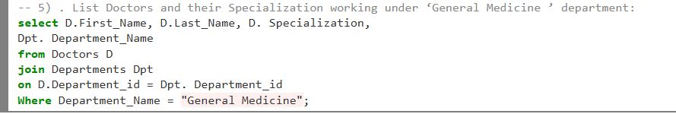

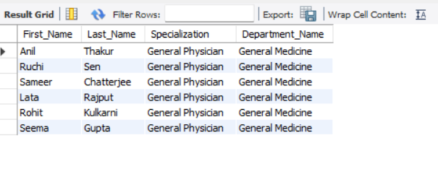

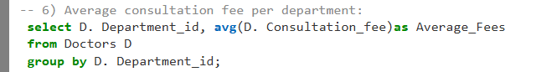

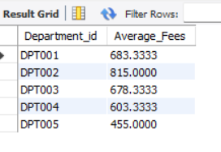

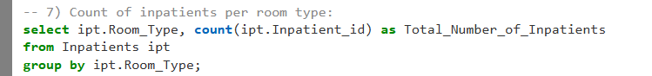

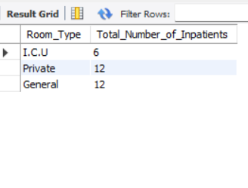

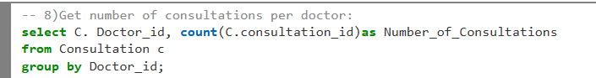

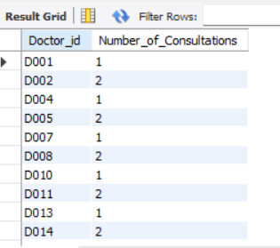

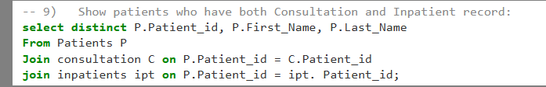

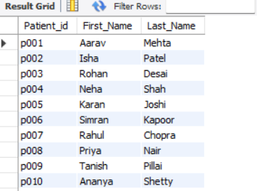

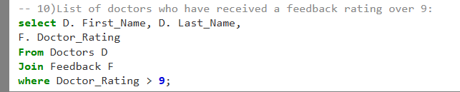

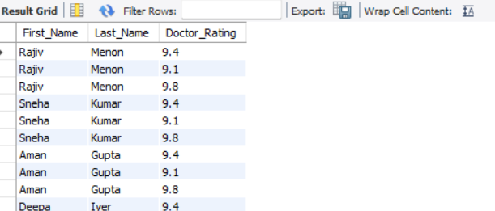

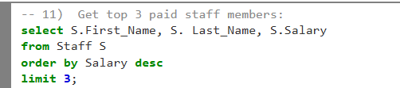

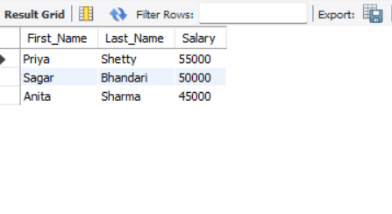

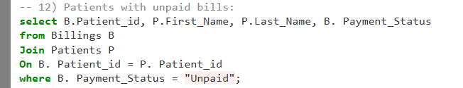

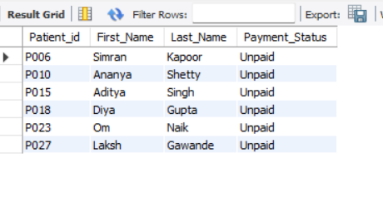

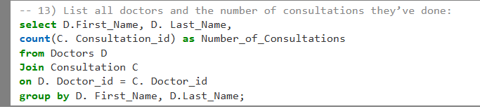

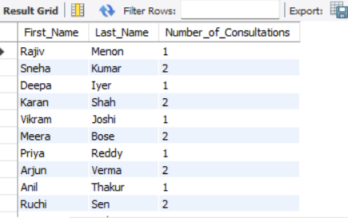

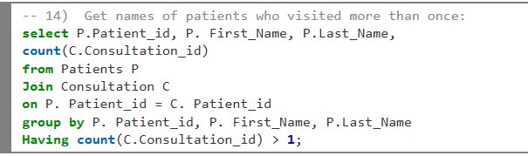

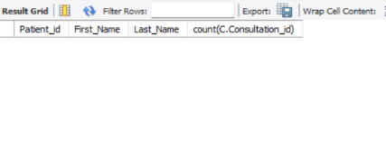

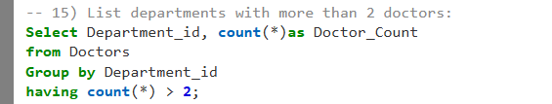

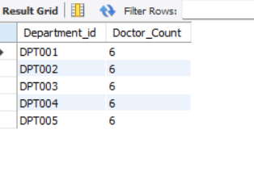

**Conclusion**

The Zenith Medical Center Management System provides a comprehensive and organized approach to handling hospital operations, from patient registrations and doctor consultations to billing, medication tracking, and feedback management. By replacing manual and error-prone methods with a structured database system, it ensures improved accuracy, efficiency, and accessibility of data across departments.

This system enhances hospital management by offering real-time data access, reducing administrative workload, and streamlining processes for doctors, staff, and patients alike. Moreover, the modular design of the database allows for easy scalability, making it adaptable to real-world hospital environments.

- THANK YOU--